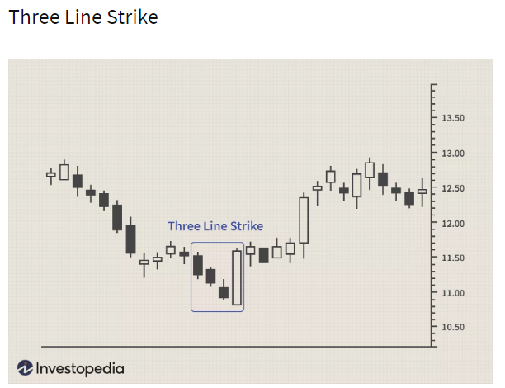

Trend will be “BULLISH” if breaks 3 red candles with a single green candle. And vice versa.

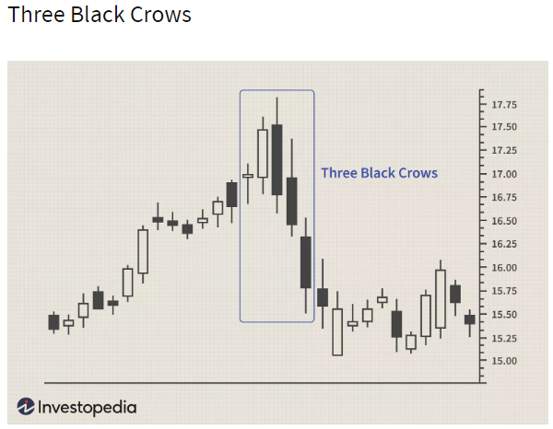

Trend will be “BEARISH” if there are 3 red candles preceded by an green engulfing candle. Preferably this pattern shud be the top of the trend. And viceversa.

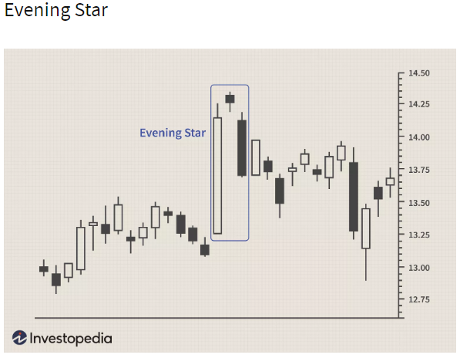

Trend will be “BEARISH”. Preferably this pattern shud be preceded by a bullish trend. And viceversa.

If it is preceded by a bearish trend, then we can see a morning star.

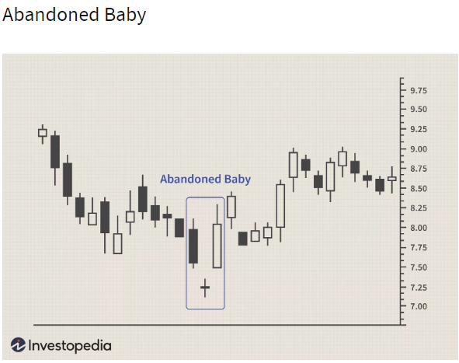

Indicates the change of the trend.

